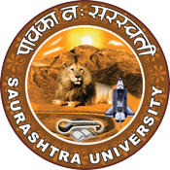
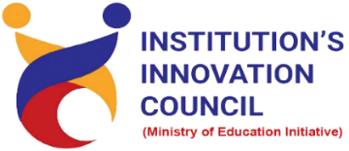

Program for environment and climate change
28th March 2023
At
Smt. R. D. Gardi Department of Business Management
Saurashtra University
Contents
Saurashtra University – IIC 2
Event Schedule 2
Event Registration Link 2
Brief about Event 3
Key Points 3
Outcome 3
About the Speaker/Chief Guest 4
5
Connect Us: 6

Saurashtra University – IIC
The university is dedicated to instruction, research, and extending knowledge to the public (public service). Ministry of Education (MoE), Govt. of India has established ‘MoE’s Innovation Cell (MIC)’ to systematically foster the culture of Innovation among all Higher Education Institutions (HEIs). The primary mandate of MIC is to encourage, inspire and nurture young students by supporting them to work with new ideas and transform them into prototypes while they are informative years. Saurashtra University is one the Organization that have constituted the IIC to foster the vision of MoE and be a part for the promotion and development of innovation ecosystem.

Event Schedule

Event Registration Link

bit.ly/SU-G20-ClimateChange

Brief about Event
Saurashtra University has taken initiatives to promote sustainable practices in university operations, including energy-efficient buildings, waste reduction and green transportation options. The initiative involves conducting awareness campaigns and programs to engage students and staff in sustainable practices.
Under this Saurashtra University and IIC have organized Program for environment and climate change on 28th March 2023 at Smt. R.D. Gardi Department of Business Management. It aims to spared awareness about climate change, natural ecosystem, Mitigation and Adaptation etc.
Impacts of rising temperatures are visible today from the poles to the equator, each region struggling with its own set of symptoms: droughts, extreme storms, floods and swinging temperatures was made understood by the speaker. Also discussed that the climate emergency is a direct consequence of our carbon-heavy land-use and agriculture, transport, buildings and industrial processes and our polluting energy sources.
The program discussed how to promote the transition to low and zero-carbon emissions in key sectors such as energy, agriculture, buildings, forestry, industry and transport. Natural ecosystems such as forests, coral reefs and peatlands should be protected and restored while tackling sources of degradation. The objective of climate change adaptation is to reduce risk and vulnerability to climate change, strengthen resilience, enhance well-being and the capacity to anticipate, and respond successfully to change.

Key Points

During the session, below mentioned points were discussed:
- Activities on sustainable development and Climate Change
- Implementation Phase
- Protecting and restoring natural ecosystems
- Empowering communities
- Nature-based solutions
- Climate Change Mitigation and Adaptation
- FAQs related to environment and climate change

Outcome

As per the event, students understood what is the cause and effect of climate change on the environment. Climate change is an ongoing natural process. The major cause for a changing climate is the variation of the naturally occurring cosmic rays. Climate change is the process of changing weather patterns on Earth. Climate change can be caused by various reasons, but it is currently known to be caused by human-induced global warming.

About the Speaker/Chief Guest

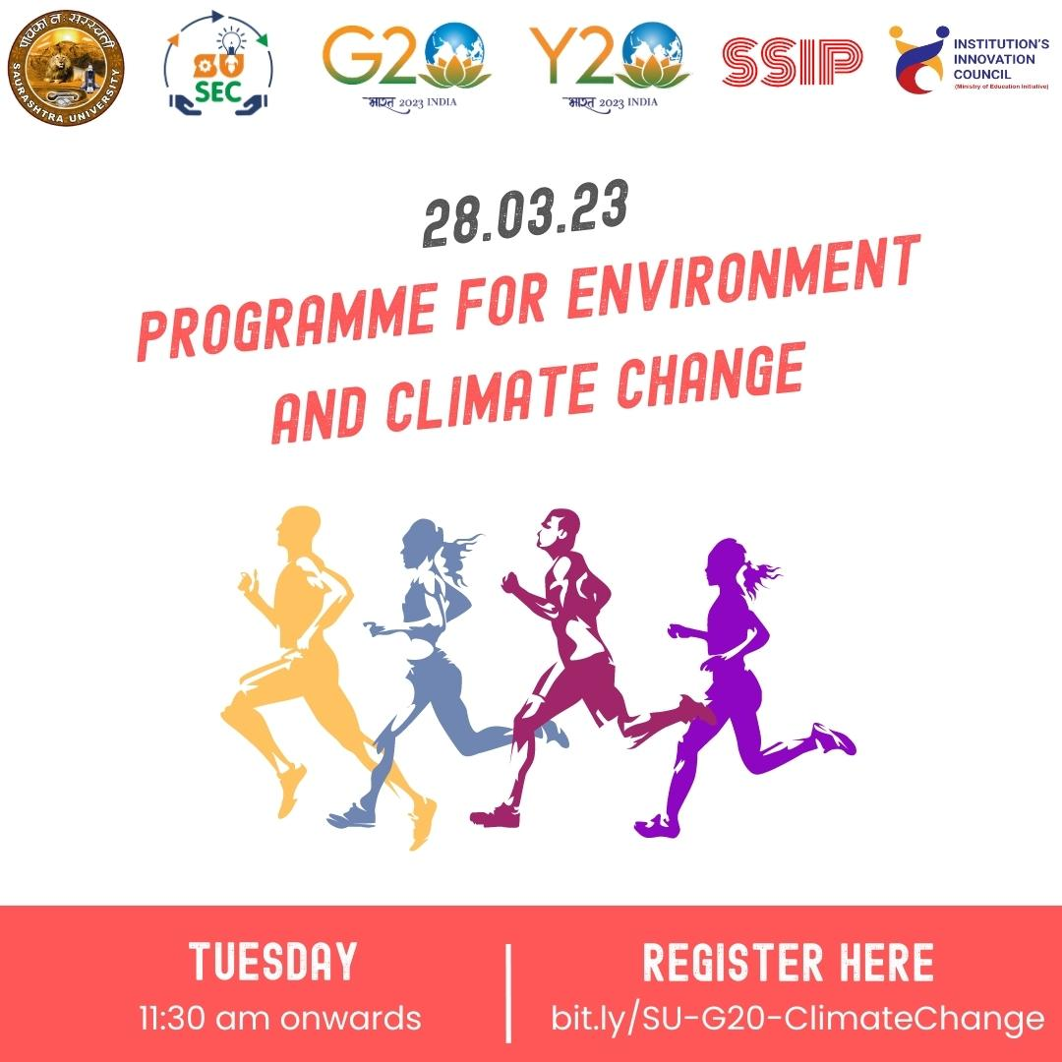

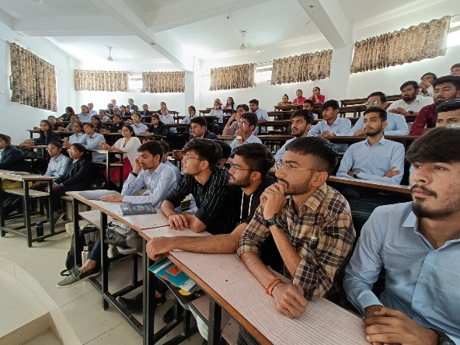
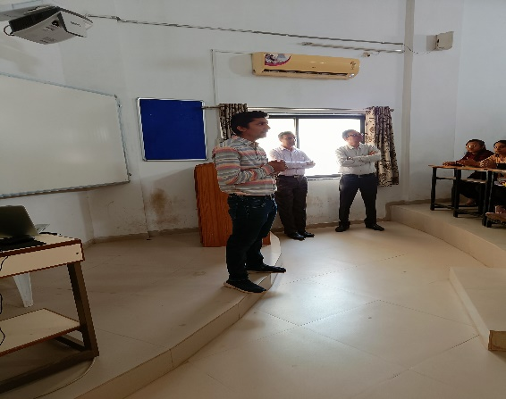
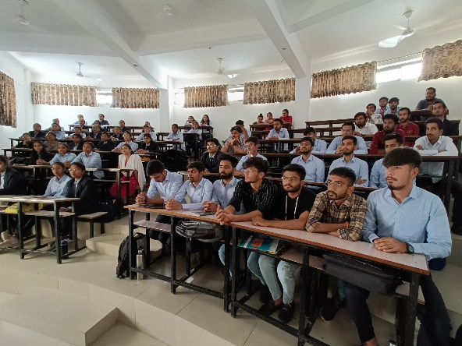
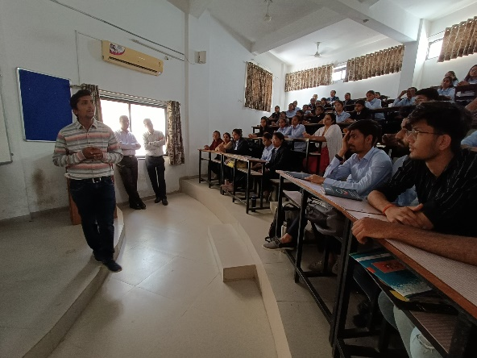
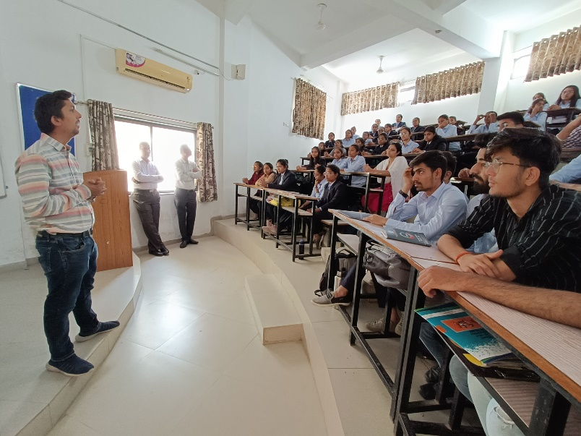

Connect Us:

https://www.linkedin.com/company/susec iic@sauuni.ac.in
https://www.facebook.com/iicsauuni bit.ly/SUSEC-Location
https://www.instagram.com/susecrajkot https://bit.ly/SUSEC-youtube

